The Civil War Lodge of Research No. 1865 AF&AM

MASONIC CORE VALUES IN ACTION: THE BOILER EXPLOSION ABOARD THE U.S.S. CHENANGO AND THE CONDUCT OF FREEMASONS

A Paper Submitted to
the Editorial Committee
for Inclusion in the Lodge’s Transactions

John M. McKee
Member, Civil War Lodge of Research No. 1865 AF&AM
PM, Myrtle Lodge No. 145 AF&AM, Oklahoma City, OK
2658 Piper Hills Drive
Shiloh, IL 62221-3455
(618) 416-5072
history_ferret@yahoo.com
True character emerges when no one is looking. How people react to sudden events reflects how well they identify and inculcate their society’s values into their daily lives. Many will exemplify those values, while others will fall short, when faced with adversity in great things and small. Core values reveal the bedrock of one’s beliefs that lead to action. They define how people act, identify themselves, and measure how society will judge them and the causes they profess. Events can serve to reveal how faithfully they represent those values through their actions and response. The event of April 15, 1864, demonstrated how people dealt with catastrophe, personal loss, and the need for accountability according to their training and beliefs. For Freemasons, that event not only revealed great sorrow for its loss, but that they also shouldered the burdens and worked toward a resolution.
Core values define organizations and their respective members. They represent fundamental values that guide behavior as individuals and as groups. These define not only an organization for its members, but also create expectations for those outside the organization as how that organization should behave and how leaders should make decisions. Core values form the group’s culture; rejecting them is to reject the group. By various associations, individuals may find compatibility between groups within their society if their core values are similar, but a source of conflict if those values diverge. The actions of individuals may not be under the direction of group leaders, but will reflect what the organization represents. Inculcating those core values are essential for the organization to exist as an ideal, achieve its purpose, and promote its vision.
Various groups have core values, whether deliberately crafted by its legitimate leaders, or informally induced by the shared experience of its members. The United States Navy’s core values can be enumerated as Honor, Courage, and Commitment. By Honor, Sailors must be ethical in all relationships, honest in all dealings, and accountable for all behavior. By Courage, Sailors must have the moral strength to do what is right. By Commitment, Sailors demonstrate their character not when needed but every day in every situation for every occasion. A single leader must articulate, exemplify, and enforce them for every Sailor without exception; otherwise, the organization’s moral fiber will weaken and fail in its mission.
On the other hand, Freemasonry is not subject to one hierarchical structure despite its international reach and its universal appeal. While most Masonic legal structure can be traced to Anderson’s Constitution, they do not represent what the profane understand as the values that motivate Freemasons, no more than the Uniform Code of Military Justice motivate Sailors. Both regulate behavior, but they do not motivate how their respective members represent themselves to those outside. Belief in the Fatherhood of God and the Brotherhood of Man are abstractions and serve to exclude people as ineligible who would not contribute to its goals. However, three values are promulgated throughout the degrees and accompanying lectures: Brotherly Love, Relief, and Truth.
These are neither duties to perform, nor rules for conduct. They represent the tenets that every member must learn and reflect in their dealings; virtues that must be practiced daily. Brotherly Love prescribes how they should treat a fellow Brother, regardless of their personal differences or circumstances. The Five Points of Fellowship enumerate the ways Freemasons should treat each other. Brotherly Love is associated with the “Column of Strength, which binds us as one family in the indissoluble bond of fraternal affection.”
The second virtue, Relief, pertains to the Freemason’s ability to mitigate misfortune through compassion. While all men should relieve the distressed as a sign of our humanity, Freemasons are more obliged to fulfill their duties formed by affection and friendships they have formed in the Fraternity. This obligation is not limited just to Brethren in the Lodge, but also to the Widow and Orphan of a Fallen Brother, and to all members of society in which he lives. Relief is associated with the “Column of Beauty, whose ornaments, more precious than the lilies and pomegranates that adorned the pillars of the porch, are the widow's tear of joy and the orphan's prayer of gratitude.”
The third virtue, Truth, represents both the journey and the destination of the Freemason, the search for Truth, which is the foundation of all virtues and by which they can know God. This virtue is expressed through “sincerity, honesty of expression, and plain dealing.” For Truth, the Freemason “travels” in his pursuit, learning and reaping from newly gained experiences, assesses his efforts, and directs his labors to the greatest good. Truth is associated with the “Column of Wisdom, whose rays penetrate and enlighten the inmost recesses of our Lodge.”
Aboard the U.S.S. Chenango were a few men with ties to the Fraternity that helped sustain them by providing the social support and camaraderie during times of prolonged absences from home and under the stress and rigors of naval deployment. While belonging to a naval organization encourages esprit de corps and cooperation among its members to work as a team, Masonic affiliation encourages stronger ties, not to the organization’s detriment, but to encourage better support of the group’s goals and a level of performance for others to emulate, just as a little leaven leavens the whole bread. Among the ship’s crew were three officers who were members of the Craft, men of highly technical training, and whose skills were in high demand when they answered their country’s call. They came from different communities along America’s Atlantic seaboard, but like many men of their trade, who were members of the middle class whose advancement in society was through their merits. They each had families they supported and loved, and by serving, hoped for a better future in their nation.
During the 19th Century, the United States Navy’s Engineering Corps represented those officers entrusted with the design and construction of ships using different materials (wood and steel), as well as the operation of the ship’s propulsion system, first steam boilers fed by coal, to be followed by engines powered by petroleum. As mechanical engineers, they had to demonstrate knowledge through written and oral examinations just to gain entrance into this select fraternity. While second only to line officers in terms of rank and size, they enabled ships to become viable platforms for conducting the Navy’s mission. After appointment, they must also learn the rules and regulations of the Navy and work as part of a larger crew encompassing a variety of skills to work as a team.
While serving aboard the U.S.S. Niphon, Second Assistant Engineer Rodney Nichols received orders to transfer to the U.S.S. Chenango that was under construction at the J. Simonson Shipyard at Greenpoint, New York. Born on December 13, 1826 in Bennington, Hillsborough County, New Hampshire, Bro. Nichols established himself first at Chelmsford, Massachusetts, and later at East Boston as his permanent home. His parents were Jonathan Nichols (1794-1836) and the former Mary D. Wilkins (1801-1875), and had four brothers and one sister. Sometime before 1848, he married Leonora Dodge, the daughter of Samuel Dodge (1798-1847) and the former Jane Dodge (1797-1849), who had one brother and one sister. They had six children, but only one son, William Rodney Nichols (1861-1945) and one daughter, Leonetta Nichols (1857-1943), survived into adulthood.
While living in East Boston, he joined the Fraternity at Baalbec Lodge (now merged with Wyoming Lodge). He was initiated July 3, 1860, passed August 7, 1860, and raised September 11, 1860. His membership was confirmed on November 6, 1860. He did not hold office, but maintained his membership in good standing until his death on June 27, 1864. He is interred at Sunnyside Cemetery, Bennington, New Hampshire.
One of his brothers, Andrew Jackson Nichols (1834-1914), had enlisted in the Union Army as part of the 29th Iowa Infantry regiment. His brother-in-law, Samuel Gilman Dodge (1821-1862), served in “D” Company, 11th New Hampshire Volunteers, and was killed in action at the First Battle of Fredericksburg. On March 31, 1863, he received his commission as Acting Second Engineer and was assigned to the U.S.S. Niphon. In November 1863, he received orders to report to the U.S.S. Chenango in support of its commissioning and preparation for service. As the ship was about ready to put to sea, he was promoted to Acting First Assistant Engineer and transferred to the U.S.S. Otsego, a ship of the same class as the U.S.S. Chenango, in preparation of its launch. He continued to serve aboard the USS Otsego until he was diagnosed with a severe respiratory illness and ordered home. Soon after reaching home, he died.
However, another Mason replaced Brother Nichols, the newly appointed Acting First Assistant Engineer Albert S. Murray, a Brother from Arcana Lodge No. 110 AF&AM, Baltimore, Maryland, and was born on May 11, 1835. The 1850 Census record indicated that he originated from the town of Frederick, Maryland, and that he later moved to Baltimore. Based on this record, he was likely the son of Thomas B. Murray, who was Armorer for the State of Maryland. At Baltimore, he was enrolled in the Maryland Institute for the Promotion of Mechanic Arts (now the Maryland Institute College of Art), winning first prize for his class in steam engines in 1857. In 1858, he married the former Adelaide Merchant (1839-1894), daughter of Isaac Merchant (1805-1861) and the former Adelaide Stiff (1812-1877). He also had two children, James Albert Murray (1859-1905) and Helen Murray (1861-1916).
Bro. Murray petitioned Arcana Lodge No. 110 AF&AM, of Baltimore, Maryland, on March 18, 1861. He was elected for membership and initiated April 1, 1861, passed April 1, 1861, and raised April 15, 1861. The Worshipful James W. Bowers was Master of the lodge. He did not hold office in the lodge. He was the thirty-ninth member initiated into the lodge since its charter in 1859. In addition, he was a member of Oriental Lodge No. 52 IOOF.
The Port of Baltimore was a major source of men for the merchant marine and Naval service, and Brother Murray was no exception. He had established himself as an engineer, and, as such, was in great company with many other engineers serving in the United States Navy. He was commissioned as a Third Assistant Engineer (see Figure 1) on February 19, 1861, serving aboard the U.S.S. Colorado, followed by an assignment aboard the USS Sangamon. Later, he was promoted to Second Assistant Engineer January 16, 1863, and later directed to the U.S.S. Mackinaw. Effective February 16, 1864, he was transferred to the U.S.S. Chenango. At that time, his wife was expecting their third child.
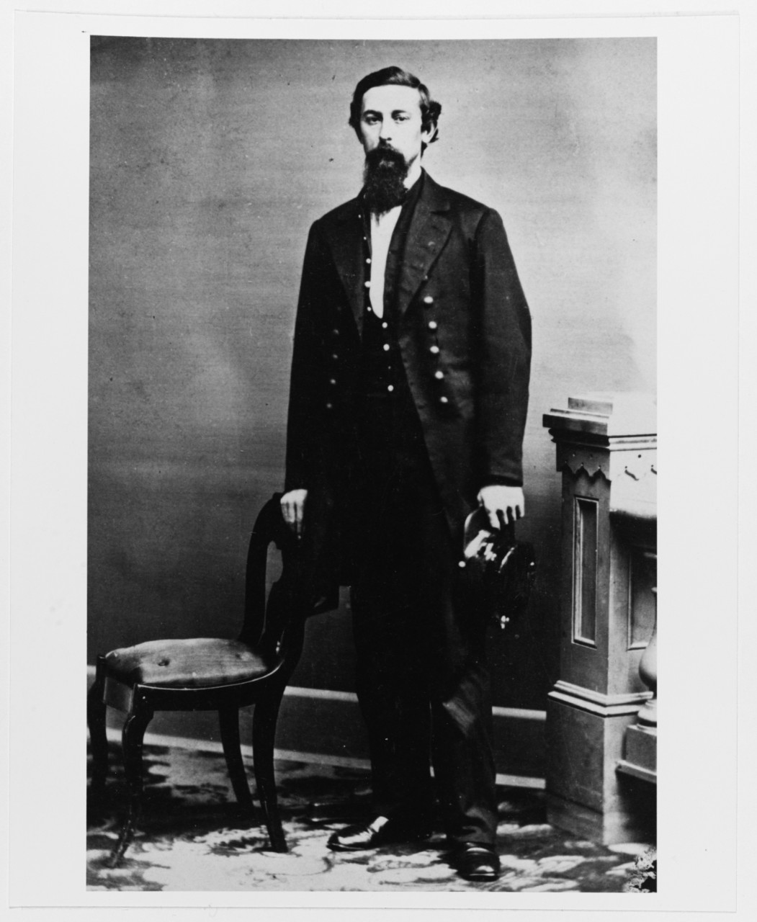
Figure 1. Albert S. Murray in the uniform as a Third Assistant Engineer, likely taken soon after his appointment in 1861. This was part of a collection of photographs belonging to Chief Engineer Frederick G. McKean, and donated by his heirs. (Source: Item NH47639, Naval History and Heritage Command, accessed March 7, 2016, from http://www.history.navy.mil/our-collections/photography/numerical-list-of-images/nhhc-series/nh-series/NH-47000/NH-47639.html)

Another member of the Fraternity assigned to the ship was Acting First Assistant Engineer Frank Pond Root. Born in Hartford, Connecticut, on April 3, 1834, his family moved to New York while maintaining ties with Hartford. Among his distant relatives was the future statesman Elihu Root (1845-1937), who was his seventh cousin once removed. His parents were Jeremiah D. Root (1810-1875) and the former Hannah Webster Pond (1807-1871). Though only surviving son out of three boys, he did have a sister, Ella Root (1843-1923). His first wife, the former Mary Jane Champlin (1835-1859), bore him two sons, Frank A. (1857-1859) and Edward Samuel (1855-1928). In 1860, he remarried, a widow named Elizabeth Eleanor Smith (née Hansel) (1836-1921), who had two children from her previous marriage: Charles Henry Smith (born 1856) and Mary Elizabeth Smith (1852-1936). At the beginning of the War, he was living with his one surviving son, wife, and two stepchildren in the Gowanus neighborhood of Brooklyn. His last living descendant was his great granddaughter, the artist Ednah Root (1907-1987).
His Masonic affiliation can only be inferred based on his burial. He had lived most of his life in Connecticut and New York. The brethren of Hoboken Lodge No. 35 F&AM of Hoboken, New Jersey, handled his burial and he was interred at the Fortitude Lodge section of Cypress Hills Cemetery. Discreet inquiries have not yielded any membership information. However, his son, Edward, was a member of Astor Lodge No. 603 F&AM, Manhattan, New York.
He received his appointment from the U.S. Navy as an Acting Second Assistant Engineer on December 10, 1861. He was assigned to the USS Potamska, where he served for the next two years. On October 3, 1863, he was reassigned to the USS Dawn with an appointment as Acting First Assistant Engineer. On December 21, 1863, he was ordered to report to the USS Chenango being fitted at New York.
Members of Fortitude Lodge No. 19 F&AM included Hospital Steward Charles Lane Kirby, who was a native of Baltimore, Maryland, born around 1834. In 1855, he enlisted in the US Navy out of Norfolk, Virginia, listing “printer” as his occupation. His service eventually brought him to the New York Navy Yard at Brooklyn, New York, working at the Hospital as early as 1860. He petitioned Fortitude Lodge No. 19, F&AM, and was initiated March 13, 1862, passed March 20, 1862, and then raised April 10, 1862. In 1863, he was elected to the South. He did not move on to the West the following year, but was active in supporting lodge activities, such as a dance held in both March 1863, and January 1864. He was dropped for nonpayment of dues in 1872, and he died while in Pikesville, MD, tending to relatives in January 1874.
Bro. William Taylor was elected to the East in 1863, and was serving again in 1864. Born in New York in 1821, he was a carpenter by trade. He petitioned for membership, and was initiated January 26, 1860, passed February 2, 1860, and raised February 23, 1860. Despite being dropped for three years, he was restored and continued in good standing until his death in 1886.
Other members of note to this event were Thomas A. Craig, L. Seamon “Seth” Shirley, and John J. White. Bro. Craig was a painter at the Navy Yard, born in Ireland in 1833. He was initiated September 1, 1859, passed September 8, 1859, and raised October 6, 1859. He served as Senior Warden in 1863 and 1872, and served in the East from 1875 through 1878. He continued faithfully in membership until his death in 1891.
Bro. White was born in Brooklyn in 1829, and was a liquor dealer. He was initiated January 30, 1862, passed February 6, 1862, and raised February 27, 1862. He continued his membership until he demitted in 1880.
Bro. Shirley originated from New York around 1825 and was a ship’s carpenter. He was initiated April 23, 1863, passed May 7, 1863, and raised June 4, 1863. He was dropped for non-payment of dues in 1868.
Finally, other Masons to be addressed are William Henry Wallace, and George B. Riggins. Bro. Wallace was a native to Brooklyn, born in 1831, and started his profession as a mechanical engineer with the Allaire Iron Works. He then became an iron and steel merchant, first as Wallace & Buckley, and later William H. Wallace & Co. An active Episcopalian, he was also active in the city’s social life. He was a member of Stella Lodge No. 485 F&AM, and became a thirty-third degree Mason in the Scottish Rite. He died in 1915.
Bro. George B. Riggins was a machinist for the Morgan Iron Works, which produced the ship’s steam engine and boilers. Born in 1829 in New York, he too went through the normal training for machinists. He was a member of Henry Clay Lodge No. 277 F&AM of New York City, serving as its master in 1875. He laid down his working tools in 1896.
The event that binds these brethren together occurred aboard this vessel, the U.S.S. Chenango. The vessel was known as a double-ender, a gunboat designed for blockade duty off the Confederate coastline, yet capable of operating up and down its rivers. It was a unit of the Sassacus-class of ships, of which many were made (see Figure 2). Launched on March 19, 1863 from the J. Simonson shipyard at Greenpoint, New York, its preparation and delivery to the Navy took nearly a year, as it experienced delays with its outfitting, engine testing, and manning. The ship was finally commissioned on February 29, 1864, and made ready for its first deployment to the South Atlantic Blockade Squadron under Rear Admiral John Dahlgren. Commander Thomas Scott Fillebrown was appointed as its first commanding officer.
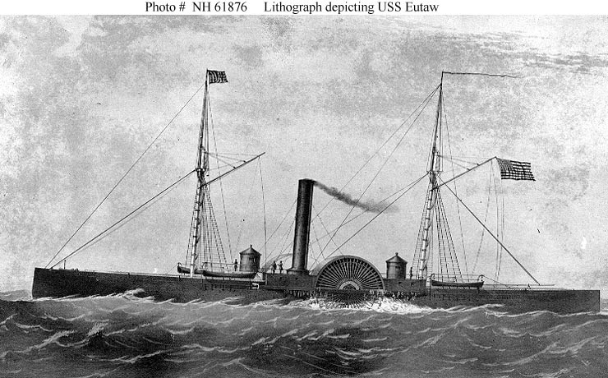
Figure 2. While no pictures have been identified of the USS Chenango, USS Eutaw had the same dimensions and armaments as opposed to most other ships of the Sassacus-class of double-enders. (Source: Item NH61876, Naval History and Heritage Command, accessed March 7, 2016, from http://www.history.navy.mil/our-collections/photography/numerical-list-of-images/nhhc-series/nh-series/NH-61000/NH-61876.html.)

Of particular note was the twin engines needed for its propulsion of its side paddle wheels, which were the Martin vertical water-tube steam engines constructed by the Morgan Iron Works. Unfortunately, problems arose with the engine apparently due to poor workmanship. Several times, the navy engineers, namely First Assistant Engineer Joseph N. Cahill, required changes or repairs to the boilers. The Martin boilers, while used in several ships already in commission, proved unreliable and maintenance-intensive (in fairness, other shipboard boilers proved equally problematic). The use of steam power, though expanding throughout transportation and industry, did have issues such as boiler explosions. Construction and operation were two important aspects when considering the safe operation of steam propulsion, regardless of design employed.
One last test was the 96-hours’ trial before delivery, which ran the boilers continuously for 96 hours without stop with ship docked at the manufacturer’s facility. This standard test was designed to determine weaknesses in the design, construction, and operating procedures of the engines before deployment. Representing the Government as inspector, Second Assistant S. Wilkins Cragg accepted the Chenango’s boilers from the contractor. Despite issues found during the trial, the boilers withstood the requisite pressures. The ship was then made ready to proceed. Engineer Murray had expressed reservations to the boilers as whether they were fit to go to sea. However, no one decided to keep the ship longer in port.
In the afternoon of April 15, 1864, Commander Fillebrown gave orders for the crew to cast off from the New York Navy Yard and proceed on its maiden voyage south. After an hour under steam, the ship passed the site of the future Verrazano Narrows Bridge, with Forts Lafayette and Hamilton to port, and Fort Richmond to starboard (see Figure 3). The time was 4:15 p.m. Fillebrown had just emerged from below after speaking to Engineer Cahill when a massive explosion erupted from below decks. Several men above deck were knocked down, but below decks the situation was direr. The port boiler burst and had sprayed steam and superheated water among the personnel at their stations, with many inhaling the scalding blast. Thirty-three were scalded with no reports of injury from shrapnel. In addition, small fires broke out and the ship’s structure around the boiler was damaged. With its engine shut down, the ship went dead in the water.
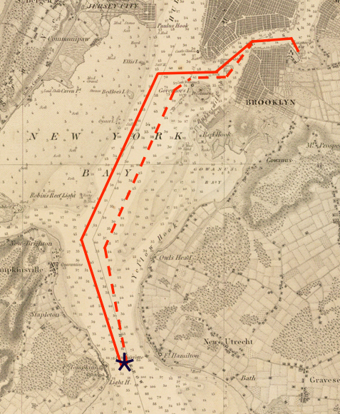
Figure 3. Route of the USS Chenango on April 15, 1864. The ship left the New York Navy Yard at 2:45 p.m. and had reached the Narrows at 4:15 p.m. (red solid line), when the ship was directly in line between Fort Richmond and Fort Lafayette, the port boiler exploded (star symbol). The ship was dead in the water. At least four vessels came to its aid. The wounded were evacuated. By 9:00 p.m., the ship was back at the Navy Yard (red dotted line). (Source: United States Coast Survey: Map of New-York Bay and Harbor And The Environs Founded upon a Trigonometrical Survey under the Direction of F.R. Hassler . . . 1845, accessed from www.raremaps.com.)
Other ships nearby noticed the explosion and immediately came to the Chenango’s aid. First on the scene was the commercial tugboat William E. Cheney, followed by the U.S. Revenue Cutter Bronx. Soon, the U.S. transport ship Tilley and the Navy tugboat U.S.S. Rose also came to render aid. Their crews assisted with providing care to the wounded, help put out the fires, and turned the ship around and towed it back to port. Fillebrown ordered the wounded loaded aboard the Rose and dispatched to the hospital, which it did. When the Chenango reached the dock at 9:00 p.m., members of the Navy medical staff were waiting to treat the rest and transport them to the U.S. Navy Hospital (see Figure 4).
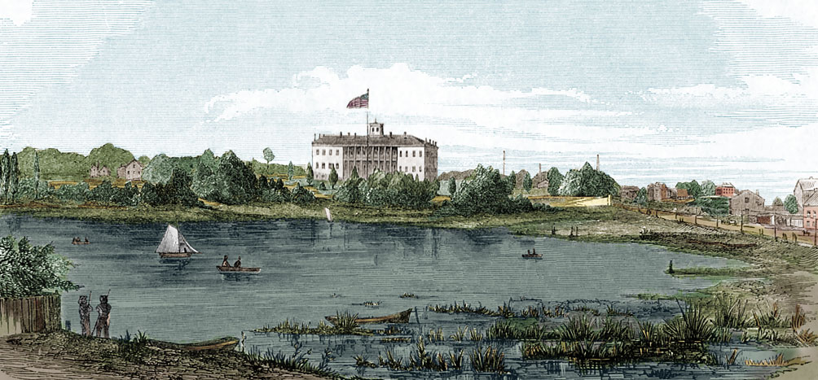
Figure 4. The US Navy Hospital as seen from Wallabout Bay, circa 1857. The foreground swamp was drained by 1864. Flushing Ave is to the right, the cemetery to the left behind the copse of trees. (Source: accessed from http://whitmans-brooklyn.org.)
For most of the wounded, the scalding inflicted a slow death. Five crewmembers were already dead when the ship evacuated its wounded. Care was given to each crewmember, trying to reduce the suffering. Family members from the local area were waiting or on the way to help or comfort them. Sadly, many reached there in time only to claim a body of a man who just expired. Engineer Murray was “extensively scalded over the body and extremities” and was in “a state of collapse.” Bro. Taylor (perhaps summoned by Bro. Kirby) heard the news and came to the hospital to help. He remained with Bro. Murray until he died at 3:00 a.m. on the morning of April 16, 1864. The Brethren of Fortitude Lodge No. 19, F&AM, Brooklyn, New York, took charge of the body for escort back to his native Maryland.
The case of Bro. Root was more heart wrenching, as his wife and children lived in Brooklyn. She had arrived as soon as he was brought into the hospital, but was highly excited and was not permitted to see him. Her husband was in “dreadful agony” because of the extensive scalding across his body and extremities. He died at 1:30 a.m. on April 16, 1864. The Brethren of Hoboken Lodge No. 35 F&AM, Hoboken, New Jersey, took charge of his body for burial.
Bro. Kirby, as Hospital steward, continued his ministering to the injured, dying, and the dead. He oversaw the assignment of nurses and their relief to ensure that every patient, regardless of his prognosis, received the care of his wounds and a measure of compassion during their final moments. He worked non-stop the first 24 hours, being unremitting in his attentions. To him also was assigned the sad task of directing attendants to remove the dead to a building known as the “dead house.” Of the 33 who were scaled, 28 died.
However, Bro. Kirby’s duties did not end there. He also superintended the memorial services.
On April 18, 1864, a funeral was held for all those who had died, not just those whom family and friends had claimed, but also those apparently forgotten. Working with the Hospital chaplain, the Rev. Dr. Charles Stewart, and a local clergyman, Bro. Kirby laid out and orchestrated a large ceremony. For those who did not have a coffin provided by private means, he arranged plain coffins. A large grave in the hospital burying ground was prepared to receive those whose family could not afford a private burial plot or who had no family to claim them, but only six were laid out singly. Beginning at the hospital chapel, the sermon was given, and afterwards, sailors carried the seventh coffin with the caps of seven victims on top to join his comrades (see Figure 5). Preceding the coffin was the Navy band, followed by a detachment of 20 seamen, a guard of Marines, several of the Chenango’s officers, and followed by civilians, Freemasons, and others.

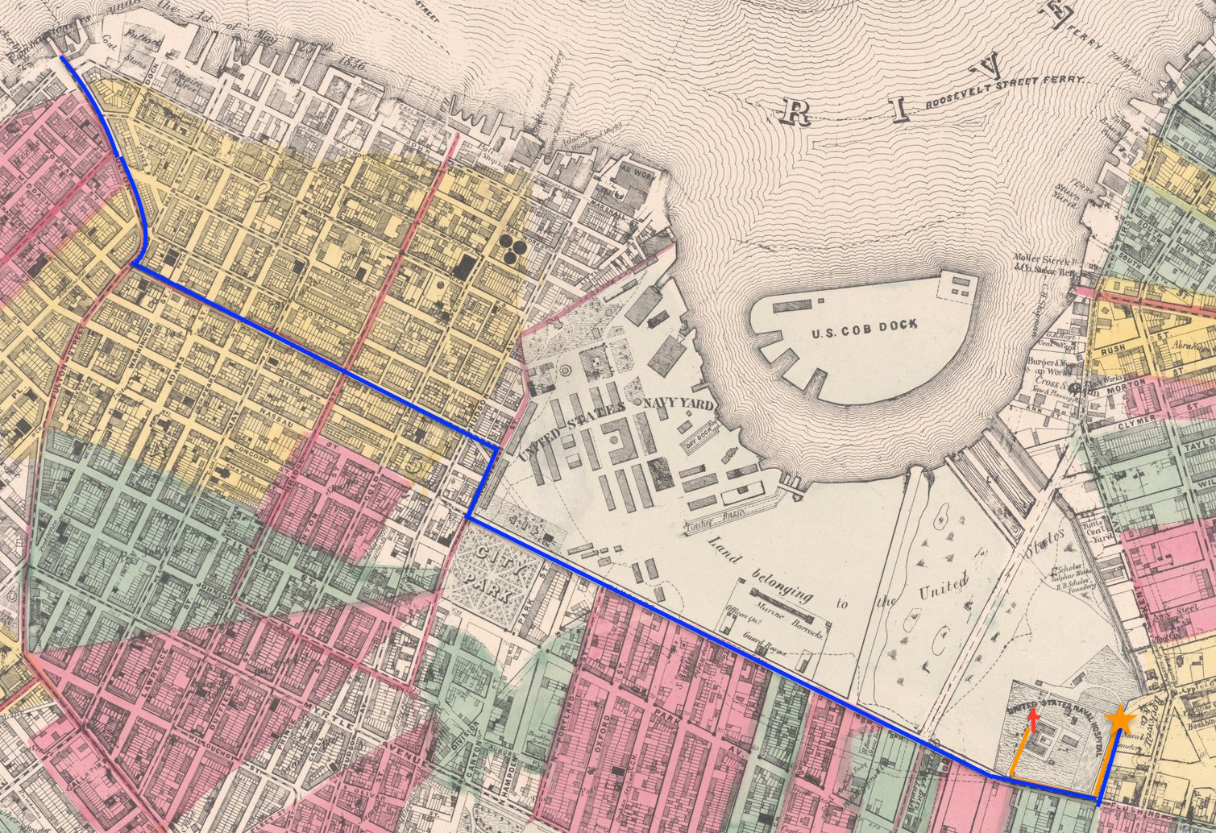
After the graveside service, a Masonic ceremony was held for Bro. Murray by the Brethren of Fortitude Lodge No. 19 F&AM, with Bro. Kirby and Bro. Thomas Craig marshaling the exercise. Bro. Taylor performed the ceremonies, and afterwards, the casket was placed in a hearse to be brought to the ferry for shipment home by railroad, with the band from the U.S.S. North Carolina heading the procession. Brothers Taylor, Shirley, and White accompanied the body to his home in Baltimore. Engineer Cahill’s body was also transported to Baltimore.
Figure 5. Route of the funeral procession (orange line) from the Naval Hospital (red cross) to cemetery (orange star) and route of Bro. Murray’s coffin from the cemetery to the Brooklyn Ferry (blue line). (Source: Lionel Pincus and Princess Firyal Map Division, The New York Public Library.)
The casket containing Bro. Murray’s body reached Baltimore to be received by his widow and children the next day. After lying in the home’s parlor, the casket was taken on April 19, 1864, by the Brethren of Arcana Lodge No. 110 AF&AM, with assistance of the Brethren of Fortitude Lodge, and the members of Oriental Lodge IOOF, for burial at Mount Olivet Cemetery. The Worshipful Dr. J. Irvin Smith was the Master of Arcana Lodge, while Bro. E. P. Barrington was Senior Warden, Bro. Barth was Junior Warden, Bro. James W. Bowers was Secretary, and Bro. John Hay was Treasurer.
The Brethren of Hoboken Lodge No. 35 took Bro. Root’s body for internment the same day as the Navy Yard funeral. News accounts mentioned Greenwood and Evergreen cemeteries as the location, but queries resulted in negative answers. Finally, a response from Cypress Hills Cemetery yielded a positive answer. Bro. Root was interred at the Fortitude Lodge section of the cemetery.
The duties of Freemasons did not end with a burial. Loss of lives and damage of Government property during a time of war require answers, truthful answers, to understand the cause and prevent recurrence, and, if necessary, hold people accountable. While the U.S. Navy conducted its own investigation, the Kings County Coroner, Dr. Norris, impaneled a jury to investigate the cause. The jury consisted of nine men, most of whom were engineers. They called 42 witnesses, most of whom were engineers, machinists, or boilermakers, providing either direct, expert, or material testimony. Two such witnesses were Bro. William Henry Wallace and Bro. George B. Riggins.
Bro. Wallace testified as to type and quality of the iron ore used for manufacturing the boiler. He noted that the best iron ore was used for making boilers and that his firm, Wallace & Buckley, provided the iron used for making this boiler. One implied conclusion of the jury was that the material used for the boiler was not a factor in the explosion.
Bro. Riggins testified as to the performance of the engine during its 96-hour trial. He noted issues about the boiler’s performance and was concerned about its safety. The pressure cited was more than the pressure that was noted when the boiler exploded. His testimony contributed to the finding that supported the Minority Verdict.
The Coroner’s Jury rendered two verdicts that varied as to how much the boiler was the source of problems. The minority verdict ascribed the disaster from low water and superheated steam. The majority verdict assigned the cause to improper bracing, stating that the inspector should be censured. Later, the National Academy of Sciences investigated the boiler explosion and supported the majority verdict, citing that the bracing did not have enough “iron below to resist the strain for which the brace is calculated.” Later, a naval court of inquiry held by the U.S. Navy determined that Second Assistant Engineer Cragg was negligent of duty and was dismissed. He appealed because:
“Owing to the haste with which vessels were built in those days and the constant pressure always bearing upon the contractors to hurry their work along, Mr. Cragg proved he was unable to control the nature of the work under his inspection and that his dismissal was unjust. About two years later he was restored to the navy, and a few years afterward resigned.”

Each of the Masons noted in this monograph have demonstrated at least one of the Fraternity’s core values during this episode. Brotherly love is “the foundation and capstone, the cement and glory of this ancient fraternity” and is exemplified through the Five Points of Fellowship. Because of Brotherly Love, Bro. Taylor visited Bro. Murray and comforted him during his final hours. However, this act was not a response to a stranger’s cries, but one offered to someone who likely have developed friendship through the latter’s sojourn of the previous two months. Because of Brotherly Love, the Craft of Fortitude Lodge worked together to give Masonic honors, not once, but twice, to Bro. Murray. Because of Brotherly Love, they escorted the body back to his home in Baltimore, ensured his burial in familiar land, and attested to his character.
Relief is given “for improving the physical and moral condition of the race.” Bro. Nichols, Bro. Murray, and Bro. Root left their families and private professions where they excelled to answer their country’s call. They endured personal hardship, a strict discipline, and exposure to danger. Their patriotism was not called into question or their competence into doubt. They gave up all their tomorrows. Bro. Kirby applied himself to his duties as Hospital steward, ensuring that those under his care would be comforted as humanly possible. No one found his efforts lacking. For those who were beyond relief, he addressed the family and friends to assure them that they would receive a proper burial and that honors due would be given. The brethren who escorted Bro. Murray’s coffin back to Baltimore assured his widow and orphans that no further harm would come to the body, and the brethren of Arcana Lodge assisted with the funeral.
Truth is the “attribute of Him in whom there is no variableness nor shadow of changing.” Bro. Murray and Bro. Root were at their post when the tragedy occurred, and had to be carried away. Whatever happened was not the result of their actions, but they acted to the best of their knowledge to ensure that the engine operated efficiently and safely. Bro. Murray was forthright about his concerns about the engine, as was Bro. Riggins. Both Bro. Wallace and Bro. Riggins to the best of their knowledge on the mechanical arts when called to testify, and, as such, elements of their testimony can be found in both the jury verdicts and the report of the National Academy of Sciences. For all these members of the Craft, on this occasion, no one can question their actions or find anyone else to be morally superior. They proved themselves as good men and true.
The event of April 15, 1864, one full year before the death of the Great Emancipator, was a sad day for many families and friends. Whatever optimism they had for a successful conclusion of the war was eclipsed by accident far from any battlefield. Arms and technology prove themselves inadequate. The only means that these people had was to be found within, in their core values, to sort out and endure the sorrow, anger, and loss. For members of the Fraternity, Brotherly Love, Relief, and Truth proved sufficient to sustain and guide them in their special duties they had to each other and to society in general.

REFERENCES
Ancestry.com – genealogical information and records.
Bennett, Frank M. The Steam Navy of the United States: A History of the Growth of the Steam Vessel of War in the U.S. Navy, and of the Naval Engineer Corps. Pittsburgh: Press of W.T. Nicholson. 1896.
Boyer, Samuel Pellman. Naval Surgeon: Blockading the South, 1862-1866. Bloomington, IN: Indiana University Press, 1963.
Callahan, Edward W., ed. List of Officers of the Navy of the United States and the Marine Corps from 1775 to 1900. New York: L. R. Hamersly, 1901.
Fold3.com – military service records.
Fultonhistory.com – newspaper accounts.
GenealogyBank.com – newspaper accounts.
Heinmiller, Gary L. “Craft Masonry in Manhattan, New York County, New York, Vol. 2.” Accessed from http://www.omdhs.syracusemasons.com/content/masonic-history.
History and By-Laws of Arcana Lodge No. 110. Baltimore: Waverly Press. 1934.
Lionel Pincus and Princess Firyal Map Division, The New York Public Library. "Sheet 6: Map encompassing Boerum Hill, Cobble Hill, Brooklyn Heights, Downtown Brooklyn, Vinegar Hill, Fort Greene, Clinton Hill, Brooklyn Navy Yard and South Williamsburg." New York Public Library Digital Collections. Accessed March 7, 2016. http://digitalcollections.nypl.org/items/510d47e2-49e7-a3d9-e040-e00a18064a99
Mackey, Albert Gallatin. A Lexicon of Freemasonry: Containing a Definition of All Its Communicable Terms, Notices of its History, Traditions, and Antiquities, and an Account of All the Rites and Mysteries of the Ancient World. London: Richard Griffin & Co. 1860.
Massachusetts Grand Lodge of Masons Membership Cards 1733–1990. New England Historic Genealogical Society, Boston, Massachusetts.
McKean, Fred G. “Baltimore and Some Early Years in the Engineer Corps, U.S.N.” Journal of the American Society for Naval Engineers, 31, no. 2 (May 1919): 420-429.
National Academy of Sciences. Annual Report for 1864. “Appendix D. Report on the Explosion of a Boiler on the United States Gunboat Chenango.” Washington: National Academy of Sciences. 1865.
Newspapers.com – newspaper accounts.
Seventh Census of the United States, 1850; (National Archives Microfilm Publication M432, 1009 rolls); Records of the Bureau of the Census, Record Group 29; National Archives, Washington, D.C.
Silverstone, Paul H. Warships of the Civil War Navies. Annapolis: Naval Institute Press. 1989.
Smolicz, Jerzy. “Core Values and Cultural Identity,” Ethnic and Racial Studies, 4, no. 1 (January 1, 1981): 75-90
School Student Lists. Worcester, Massachusetts: American Antiquarian Society.
The Boiler Explosion of the Martin Boiler on board the U.S. "Double-Ender" Chenango: The Coroner's Inquest, a Full Report of the Testimony, the Charge of Dr. Norris to the Jury, and the Two Verdicts. New York: Hurd & Houghton. 1864.
The New York Times Article Archive. Accessed from http://www.nytimes.com/ref/membercenter/nytarchive.html
US Department of Health and Human Services. Health Resources and Services Administration. Bureau of Primary Health Care. “Vision, Mission, and Core Values.” Accessed February 15, 2016. http://bphc.hrsa.gov/archive/technicalassistance/resourcecenter/general/visionmissioncorevalues.pdf.
US Department of the Navy. Case Files of Approved Pension Applications of Widows and Other Dependents of Civil War and Later Navy Veterans (Navy Widows' Certificates), 1861-1910.
US Department of the Navy. Office of the Secretary of the Navy (SECNAV). August 23, 1999. “Department of the Navy (DON) Core Values Charter.” SECNAV Instruction (SECNAVINST) 5350.15A. Washington, DC.
U.S. Department of the Navy. Records of the Bureau of Medicine and Surgery. Record Group 52. Hospital Tickets and Case Papers, compiled 1825‒1889.
Wyllie, Arthur. The Union Navy. Raleigh: Lulu.com. 2007.
Your Dictionary. “Examples of Core Values.” Accessed February 15, 2016. http://examples.yourdictionary.com/examples-of-core-values.html.

Acknowledgements
Researching this project has grown from researching one person to understanding the various connections of people and places, shaking off suspicions with evidence, straightening out concepts, and just being helpful. First, I want to thank Dr. James Delgado, NOAA, who explained the cause of the explosion; R∴W∴ Bro. Joel A. Hilsenrath, secretary of Midwood-Fortitude Lodge No. 19 F&AM for information regarding his lodge members and even chasing down a few loose threads; R∴W∴ Bro. Walter H. Hunt, Librarian at the Samuel Crocker Lawrence Library, Grand Lodge of Massachusetts for information on Rodney Nichols; Carolina Padin, Cypress Hills Cemetery, for answering many queries; members of the U.S. Navy’s History and Heritage Center for responding to a lot of technical queries; and Janice Goldblum at the National Academy of Sciences for providing the report and how they were prepared. I realized later that the project could eventually be expanded to become a book that goes beyond the Masonic aspect. As a result, I have consulted many others whose help would become recognized should that book be realized, but I am no less thankful now.

Note on research

Writing this article as much as thirty years ago would have been beyond the resources that researchers would be have been able to achieve within the given time. The information is dispersed through various repositories, would have been only available as hardcopy, and would have required considerable time and expense through travel and correspondence before much information could have been obtained. Worldcat.org has been helpful in identifying the repositories and archival collections. The electronic media available through telecommunications has enabled much of the information to be retrieved very quickly and cheaply. At one extreme, the medium provided someone who can share the information upon request, and at the other extreme to downloading the information through simple queries using search engines. Subscription sites can provide much of the information available through systematic searches. In the case of four people mentioned in this paper (Nichols, Murray, Root, and Kirby), I had created genealogical databases through Ancestry.com, allowing me to create a timeline, append sources, organize information, and discern relationships.

Note to the Profane

This article was written by a Freemason to other Freemasons for publication in a Masonic journal. The profane (i.e., non-Masons) may find references to F&AM and AF&AM, initiated, passed, and raised, etc., as needing explanation.

Two Masonic traditions emerged during the founding of this country, both reaching back to events in England. That was the controversy over the “Ancients” and “Moderns.” Originally, the Moderns charted lodges founded in British North America. A group emerged in England calling into question the authenticity of the degrees. They were called the “Ancients” in reference to their claim of pedigree. During the Revolution, the Ancients displaced several grand lodges and forced many Masons obligated under the Modern regime either to drop out or retake their oaths. (For example, Bro. Benjamin Franklin, a Modern, refused to retake this oath, and was not given Masonic honors at his funeral.) As a result, lodges were chartered as either “Free & Accepted Masons” (F&AM), or Moderns, or “Ancient Free & Accepted Masons (AF&AM) or Ancients. However, all controversy was resolved back where it originated, in England. This was realized through the formation of the United Grand Lodge of England (UGLE) during the early 19th Century, reconciling the forms and ceremonies. Consequently, the distinction was only retained through the lodge names by the time of the Civil War.

The Symbolic, or “Blue”, Lodge Masonry is the one that most people are familiar, and is the one that all men must go through before joining the appendant bodies (the Scottish Rite, York Rite, Shriners, etc.). The ritual of admission and membership go through three degrees, and are in this order: one is initiated as an Entered Apprentice, Passed to the degree of Fellowcraft, and raised to a Master Mason. They are compared to youth, manhood, and old age, stages of life that men go through to achieve enlightenment. Only as a Master Mason was full membership realized. Members had to pay dues to remain in good standing. They may hold office in the lodge. The typical elected offices are the Worshipful Master (the East), the Senior Warden (the West), the Junior Warden (the South), Secretary, and Treasurer. Deacons and stewards are appointed offices.

One important point is that Freemasonry has no worldwide hierarchy. That is, no supreme body, no supreme ruler, no grand archive, and no central bank account bind the Fraternity. Each grand lodge is a sovereign jurisdiction that regulates its members. Each jurisdiction’s leader is the Grand Master. Grand lodges mutually agree to recognize each other and other grand lodges they already hold recognition. Grand lodges are not to intrude upon the territory already claimed by other grand lodges, such as granting lodge charters in another state. Members from other jurisdictions sojourning there are subject to that grand lodge’s rules and regulations when participating in Masonic events. Appendant bodies are not tied to territory, but do require the permission of the local Grand Master to operate within his jurisdiction.

“Examples of Core Values,” Your Dictionary, accessed February 15, 2016, http://examples.yourdictionary.com/examples-of-core-values.html.
US Department of Health and Human Services, “Statement of Vision, Mission, and Core Values,” accessed February 15, 2016, http://bphc.hrsa.gov/archive/technicalassistance/resourcecenter/general/visionmissioncorevalues.pdf.
Jerzy Smolicz, “Core Values and Cultural Identity,” Ethnic and Racial Studies, 4, no. 1, (1 Jan 1981): 75.
SECNAVINST 5350.15A, 1999.
Albert Gallatin Mackey, Lexicon of Freemasonry (London: Richard Griffin & Co., 1860), 104-05.
Mackey, 286-87.
Mackey, 285-286.
Mackey, 287.
Mackey, 360-61.
Mackey, 287.
Fred G. McKean, “Baltimore and Some Early Years in the Engineer Corps, U.S.N.,” Journal of the American Society for Naval Engineers, 31, no. 2 (May 1919): 422-423.
Massachusetts Grand Lodge of Masons Membership Cards 1733–1990, New England Historic Genealogical Society, Boston, Massachusetts.
Edward W. Callahan, ed., List of Officers of the Navy of the United States and the Marine Corps from 1775 to 1900 (New York: L. R. Hamersly, 1901).
Callahan.
Samuel Pellman Boyer, Naval Surgeon: Blockading the South, 1862-1866 (Bloomington, IN: Indiana University Press, 1963), 306.
Year: 1850; Census Place: Fredericktown, Frederick, Maryland; Roll: M432_292; Page: 19B; Image: 44.
“Eighth annual report of the board of managers and treasurer of the Maryland Institute for the Promotion of the Mechanic Arts” (School Student Lists. Worcester, Massachusetts: American Antiquarian Society), 167.
History and By-Laws of Arcana Lodge No. 110 (Baltimore: Waverly Press, 1934), 315.
History and By-Laws of Arcana Lodge No. 110, 40-41.
History and By-Laws of Arcana Lodge No. 110, 315.
“Masonic Funeral,” Baltimore Sun, April 20, 1864.
McKean, 425.
Callahan.
“Matters at the Charlestown Navy Yard,” Boston Herald, June 3, 1861.
“Naval Orders,” Daily National Intelligencer (Washington, DC), October 11, 1862.
Callahan.
“Naval Record,” Boston Daily Advertiser, November 17, 1863.
“Deaths,” New York Times, January 26, 1928.
Callahan.
“The Brooklyn Navy Year,” New York Herald, December 18, 1861.
Case Files of Approved Pension Applications of Widows and Other Dependents of Civil War and Later Navy Veterans (Navy Widows' Certificates), 1861-1910
Callahan.
“Naval Record,” Boston Daily Advertiser, December 21, 1863.
Joel A. Hilsenrath, Letter to author, dated January 20, 2016.
“Grand Masonic Ball,” Brooklyn Daily Eagle, March 20, 1863.
“Second Annual Grand Promenade Concert and Ball,” Brooklyn Daily Eagle, January 20, 1864.
Hilsenrath.
“Died,” Baltimore Sun, January 20, 1874, p. 2.
Hilsenrath.
Hilsenrath.
Hilsenrath.
Hilsenrath.
“William H. Wallace Dead,” The New York Times, July 21, 1915.
Gary L. Heinmiller, “Craft Masonry in Manhattan, New York County, New York, Vol. 2”, accessed from http://www.omdhs.syracusemasons.com/content/masonic-history.
Paul H. Silverstone, Warships of Civil War Navies (Annapolis: Naval Institute Press, 1989), 58.
Silverstone, 63.
Arthur Wyllie, The Union Navy (Raleigh: Lulu.com, 2007), 105.
The Boiler Explosion of the Martin Boiler on board the U.S. "Double-Ender" Chenango: The Coroner's Inquest, a Full Report of the Testimony, the Charge of Dr. Norris to the Jury, and the Two Verdicts, (New York: Hurd & Houghton, 1864), 6.
Benjamin E. Chassaing, “The Explosion on Board the Chenango. Letter from an Engineer,” The New York Times, May 12, 1864.
The Boiler Explosion, 138-141.
The Boiler Explosion, 7, 9, and 11.
“Sad Disaster,” The New York Times, April 16, 1864.
The Boiler Explosion, 7.
“The Chenango Disaster,” New York Herald, April 17, 1864.
“Terrible Marine Disaster,” New York Daily Tribune, April 16, 1864.
“A Terrible Catastrophe,” Brooklyn Daily Eagle, April 16, 1864.
U.S. Department of the Navy, Records of the Bureau of Medicine and Surgery, Record Group 52, Hospital Tickets and Case Papers, compiled 1825‒1889.
“Masonic Funeral,” Baltimore Sun, April 20, 1864.
U.S. Department of the Navy, Records of the Bureau of Medicine and Surgery, Record Group 52, Hospital Tickets and Case Papers, compiled 1825‒1889.
“The Chenango Disaster, The New York Times, April 18, 1864.
“The Chenango Disaster, The New York Times, April 18, 1864.
Hospital Tickets and Case Papers.
“The Chenango Disaster, The New York Times, April 18, 1864.
“The Chenango Disaster, The New York Times, April 18, 1864.
“A Terrible Catastrophe,” Brooklyn Daily Eagle, April 16, 1864.
“The Chenango Calamity,” The New York Times, April 19, 1864.
“The Chenango Calamity,” The New York Times, April 19, 1864.
“Masonic Funeral,” Baltimore Sun, April 20, 1864.
History and By-Laws of Arcana Lodge No. 110, 54-55.
History and By-Laws of Arcana Lodge No. 110, 25.
Carolina Padin, January 20, 2016, email message to author.
The Boiler Explosion. A count was made of the witnesses and their listed occupations. In addition, research was performed on the jury members as to their backgrounds.
The Boiler Explosion, 24.
The Boiler Explosion, 24-25.
The Boiler Explosion, 124.
The Boiler Explosion, 140.
The Boiler Explosion, 140.
The Boiler Explosion, 140-141.
National Academy of Sciences, Annual Report for 1864, “Appendix D. Report on the Explosion of a Boiler on the United States Gunboat Chenango,” 13-14.
“The Disaster on the Chenango,” The New York Times, July 9, 1864.
Frank M. Bennett, The Steam Navy of the United States (Pittsburgh: Press of W.T. Nicholson, 1896), 427-428.
Mackey, 42.
Mackey, 104.
Mackey, 285.
Mackey, 361.

